***“*A REPORT ON INTERNSHIP AT Vikram and Gaurav Associates, Jayanagar Bangalore*”***

***A report submitted in partial fulfillment of the requirement for the award of the Degree in***

**BACHELOR OF BUSINESS ADMINISTRATION**

**BANGALORE CITY UNIVERSITY**



Submitted By

**NAME: shoaib**

**REGISTER NO: 21**

***ACKNOWLEDGEMENT***

It is my immense pleasure to acknowledge and thank every individual, who directly or indirectly contributed to this report titled

# “Internship at VIKRAM AND GAURAV ASSOCIATES,

**Jayanagar Bangalore ”** of a total durationof **days** i.e from **21/03/2024 to 30/04/2024** which was done during the final year of the BBA degree course.

I am highly indebted to our Principal**,** for providing an opportunity to complete this project.

I express my deep sense of gratitude and

**Date**: 05/05/2024

**Place** : Bangalore

**TABLE OF CONTENTS**

|  |  |  |
| --- | --- | --- |
| **CHAPTER**  **No** | **PARTICULARS** | **PAGE NO** |
| **1** | **Organization Profile** | **4-13** |
| **2** | **Nature of Work undertaken**  by the student | **14-21** |
| **3** | **Learning outcome from the internship - Experience & Response**  by the student | **22-26** |
| **4** | **Logbook** | **27-29** |
|  | **ANNEXURES** | **30** |

**LIST OF CHARTS**

|  |  |  |  |
| --- | --- | --- | --- |
| **SL.NO** | **CHARTS NO** | **CHART TITLE** | **Pg No** |
| **1** | **CHART 1** | **Visuals of Income Tax filing procedure** | **21** |
| **2** | **CHART 2** | **Visuals of GST filing procedure** | **22** |

# CHAPTER 1

**ORGANIZATION**

# PROFILE

**Organization details:**

Vikram and Gaurav Chartered Accountants (VGCA) is a Bengaluru-based firm dedicated to providing comprehensive financial services to individuals and businesses. Established by Vikram Simha and Gaurav S R, both qualified Chartered Accountants, the firm leverages their expertise to empower clients with financial clarity and strategic guidance.

**Services Offered**

* **Taxation:** VGCA offers a robust suite of tax services, including: oIncome Tax filing for individuals and businesses, ensuring clients comply with all regulations and optimize their tax liabilities. oGoods and Services Tax (GST) consultation and filing, navigating the complexities of the GST regime for a smooth and efficient process. oTax planning and strategizing to minimize tax burdens and maximize financial benefits for clients.
* **Accounting Services:** The firm provides a full spectrum of accounting services, encompassing: oBookkeeping and record-keeping, ensuring accurate financial data entry and meticulous maintenance of accounting records, following established accounting principles. oFinancial statement preparation, creating comprehensive statements like balance sheets and income statements that provide a clear picture of a client's financial health. oStatutory audits and internal audits, offering independent assessments of financial statements and

internal control systems to ensure accuracy and identify potential risks. oManagement accounting and financial analysis, providing clients with valuable insights and reports to support informed decision-making.

* **Additional Services:** VGCA might offer additional services depending on their areas of specialization, potentially including: oBusiness registration and formation, guiding clients through the process of establishing new businesses and ensuring compliance with all legal requirements. oCompany secretarial services, handling various administrative tasks related to company law and governance. oFinancial due diligence, providing in-depth analysis of a target company's financial condition before mergers, acquisitions, or investments. oValuation services, determining the fair market value of businesses or assets for various purposes.

**Team and Expertise**

VGCA's core strength lies in its team of experienced and qualified professionals. Vikram and Gaurav, along with their team members (if any information exists about them, you can add details here), possess extensive knowledge of accounting principles, tax regulations, and financial analysis. Their commitment to ongoing professional development ensures they stay abreast of the latest industry trends and regulatory changes, providing clients with the most up-to-date advice.

**Client Focus**

At VGCA, client satisfaction is paramount. The firm fosters a collaborative approach, working closely with clients to understand their unique needs and financial goals. They prioritize clear communication, ensuring clients understand complex financial concepts and are actively involved in the decisionmaking process.

**Conclusion**

This exploration of Vikram and Gaurav Chartered Accountants provided valuable insights into the diverse services offered by CA firms. The internship program at such a firm would expose students to practical applications of accounting principles, tax regulations, and financial analysis. By assisting with tasks like bookkeeping, tax filing, and potentially even audits, interns could gain firsthand experience in the day-to-day operations of a CA practice. Furthermore, interacting with qualified professionals and observing their client interactions would provide invaluable lessons in professional communication, teamwork, and ethical conduct within the financial services industry. Overall, an internship at Vikram and Gaurav Chartered Accountants, or a similar firm, would be an enriching experience for students considering a career in accounting, finance, or business administration.

**Vikram and Gaurav Chartered Accountants: A**

**Deeper Dive into Services**

**Taxation:**

* **Income Tax Filing:**
  + **Meaning:** This service involves preparing and submitting income tax returns for individuals and businesses to the government. It ensures clients comply with tax laws and regulations, and potentially minimize their tax liabilities.
  + **Procedure:** VGCA would gather your income and expense records, analyze them to determine taxable income, calculate the applicable tax amount based on tax brackets and deductions, and then file your return electronically or on paper. o**Rules:** To file income tax returns, various documents are required, such as salary slips, investment proofs, business income and expense records, and tax payment challans (if any). Deadlines for filing vary depending on the taxpayer category (individual, company, etc.).

* **Goods and Services Tax (GST) Consultation and Filing:**
  + **Meaning:** GST is a tax levied on the supply of goods and services in India. VGCA provides guidance on navigating the complexities of GST, including registration, filing returns, claiming input tax credit, and complying with various GST regulations. o**Procedure:** The firm would advise on GST registration based on your business activity and turnover thresholds. They would assist with filing GST returns, which involve documenting sales, purchases, input tax credit, and calculating the final tax liability payable to the government.

* + **Rules:** Businesses exceeding a specific turnover threshold must register for GST. Regular filing of GST returns and adherence to invoice formats and recordkeeping are crucial aspects of GST compliance.

* **Tax Planning and Strategizing:**
  + **Meaning:** Tax planning involves analyzing your financial situation and exploring legal methods to minimize your tax burden. This could involve maximizing deductions and exemptions, utilizing taxsaving instruments, and structuring your business operations in a tax-efficient manner.
  + **Procedure:** VGCA would review your income sources, expenses, and future financial goals. They would then recommend tax-saving strategies tailored to your specific circumstances, while adhering to all legal and ethical considerations.
  + **Rules:** Tax planning should always be conducted within the legal framework. Consulting a qualified CA ensures strategies comply with tax laws and avoid any potential penalties.

**Accounting Services:**

* **Bookkeeping and Record-Keeping:**
  + **Meaning:** This involves recording financial transactions of a business on a daily basis. It includes maintaining ledgers, journals, and other financial records to ensure accurate and complete financial data.
  + **Procedure:** VGCA might utilize accounting software to record your business transactions, categorize them into different expense and income accounts, and reconcile bank statements to ensure data accuracy.

|  |  |
| --- | --- |
| •  •    11 | * **Rules:** Maintaining proper books of accounts is a legal requirement for businesses. Generally Accepted Accounting Principles (GAAP) provide a framework for consistent and accurate recording of financial transactions.     **Financial Statement Preparation:** o**Meaning:** Financial statements are reports that summarize a company's financial performance and position at a specific point in time. The main types include the balance sheet, income statement, and cash flow statement.   * **Procedure:** VGCA would gather your financial data from bookkeeping records and prepare these statements using accounting software and adhering to accounting standards. o**Rules:** Financial statements must be prepared following established accounting standards to ensure transparency and comparability for stakeholders.     **Audits (Statutory and Internal):**   * **Meaning:** An audit is an independent review of a company's financial statements to verify their accuracy and ensure they comply with accounting standards. Statutory audits are mandatory for certain companies by law, while internal audits are voluntary assessments conducted by the company itself. * **Procedure:** For statutory audits, VGCA would plan and execute the audit process, involving testing transactions and account balances, reviewing internal controls, and issuing an audit report with an opinion on the fairness of the financial statements. |

* + **Rules:** Statutory audits are governed by the Companies Act and require adherence to auditing standards. Internal audits can be customized based on the company's specific needs and risk profile.

* **Management Accounting and Financial Analysis:**
  + **Meaning:** This involves analyzing financial data to provide insights to management for informed decisionmaking. It focuses on areas like cost analysis, budgeting, forecasting, and performance evaluation.
  + **Procedure:** VGCA would analyze your financial data to identify trends, assess profitability, and evaluate the effectiveness of financial strategies. They would then prepare reports and recommendations to support management decisions. o**Rules:** Management accounting uses various analytical techniques, but there are no specific regulations governing its practice.
* **Business Registration and Formation:**
* **Meaning:** This service assists in establishing a new business by guiding you through the legal and regulatory processes. It involves choosing the appropriate business structure (sole proprietorship, partnership, limited liability company, etc.), registering the business with the Registrar of Companies (ROC), obtaining necessary licenses and permits, and complying with other legal requirements.
* **Procedure:** VGCA (if they offer this service) would advise on the most suitable business structure based on your industry, liability considerations, and future growth plans. They would then assist with:
  + Preparing and filing the necessary registration documents with the ROC.
  + Obtaining a Director Identification Number (DIN) for company directors.
  + Opening a business bank account.
  + Applying for relevant licenses and permits depending on your business activity and location.
* **Rules:** The specific registration process and required licenses vary depending on the chosen business structure and industry. VGCA would ensure you comply with all relevant regulations set forth by the Companies Act and other applicable laws.

**Company Secretarial Services:**

* **Meaning:** This service involves handling various administrative tasks related to corporate governance and compliance. A company secretary ensures the company adheres to legal requirements as outlined in the Companies Act.
* **Procedure:** If VGCA offers company secretarial services, they would typically handle tasks like: oConvening and conducting board meetings and general meetings of shareholders. oMaintaining statutory registers like the register of directors and register of members. oFiling various company documents with the ROC, such as annual reports and director's shareholding details. oLiaising with regulatory authorities on the company's behalf.
* **Rules:** Company secretaries play a crucial role in ensuring companies comply with corporate governance regulations. VGCA would have a deep understanding of the Companies Act and other relevant laws to fulfill these responsibilities effectively.

**Financial Due Diligence:**

* **Meaning:** This service involves a comprehensive analysis of a target company's financial condition before a merger, acquisition, or investment. It helps assess the financial risks and opportunities associated with the transaction.
* **Procedure:** If VGCA offers financial due diligence, they would conduct a thorough review of the target company's financial statements, accounting records, and other relevant documents. This might involve analyzing historical financial performance, assessing assets and liabilities, evaluating potential liabilities like lawsuits, and identifying any red flags.
* **Rules:** There are no specific regulations governing financial due diligence. However, VGCA would ensure the process adheres to professional auditing standards and provides a reliable assessment of the target company's financial health.

**Valuation Services:**

* **Meaning:** This service determines the fair market value of a business or its assets. It's used for various purposes, such as mergers and acquisitions, estate planning, or taxation.
* **Procedure:** If VGCA offers valuation services, they would employ various valuation methodologies based on the type of asset being valued. This might involve analysing market data, comparable transactions, income-generating capacity, or asset replacement costs.
* **Rules:** Valuation standards and methodologies are established by professional valuation bodies. VGCA would ensure their valuations adhere to these standards and provide a credible estimation of the asset's value.

**CHAPTER 2**

# NATURE OF WORK DONE

This chapter of my report details my internship experience at

Vikram and Gaurav Chartered Accountants, a CA firm located in Bengaluru, Karnataka. The internship program spanned about 39 days, providing a comprehensive introduction to the world of accounting, taxation, and auditing. During this time, I gained valuable theoretical knowledge and practical skills through a combination of training sessions and hands-on work assignments.

**Internship Structure**

The internship program consisted of two primary phases:

* **Theoretical Training (10 days):** The initial phase focused on equipping me with the theoretical foundation necessary for performing core accounting and tax functions. This included:
  + Understanding accounting principles and Generally Accepted Accounting Principles (GAAP). oExploring the Goods and Services Tax (GST) framework, including registration, return filing, and input tax credit procedures. oFamiliarization with Income Tax regulations for individuals and businesses and Tax Deduction at Source concepts.
  + Introduction to audit processes and methodologies.
* **Practical Work Assignments:** Following the theoretical training, I was assigned practical tasks to apply the acquired knowledge. This provided valuable hands-on experience in various accounting and tax domains.

1. **Practical Work Experience**
   1. **Goods and Services Tax (GST) Filing (Approx. 100**

**Companies)**

* + - **Nature of Work:** I actively participated in the GST filing process for approximately 100 companies. This involved:
      * Data collection and organization: Gathering client information like sales, purchases, input tax credit details, and place of supply. oReturn preparation: Utilizing accounting software, I prepared GSTR-3B (monthly return) and GSTR-9 (annual return) for clients, ensuring accuracy and adherence to GST regulations. oCommunication and client interaction: I interacted with clients to clarify any doubts regarding GST filing procedures and gather necessary information.
    - **Procedure:**
      1. **Client Onboarding:** The process began with onboarding new clients by collecting their GST registration details and understanding their business nature.
      2. **Data Collection:** I gathered data from clients through various means, including emails, phone calls, or directly from their accounting records. This data included sales invoices, purchase invoices, and input tax credit details.
      3. **Return Preparation:** Using accounting software, I entered the collected data into the appropriate forms. I ensured proper classification of transactions, calculation of tax liabilities, and claiming eligible input tax credit.
      4. **Review and Filing:** The prepared returns were reviewed by senior staff for accuracy and completeness before final submission to the GST portal.
      5. **Client Communication:** Throughout the process, I maintained communication with clients to address any questions or concerns they might have regarding GST filing.
  1. **Income Tax Filing**
     + **Nature of Work:** I assisted with income tax filing for various clients, including:
       - **Salaried Individuals:** I prepared income tax returns for salaried individuals, considering their income sources, deductions, and tax calculations.
       - **Businesses (2 Companies):** I assisted with tax filing for two business entities, gaining exposure to corporate tax calculations and relevant forms.
     + **Procedure:**
       1. **Client Categorization:** Clients were categorized based on their income sources (salaried, business, etc.).
       2. **Data Collection:** For salaried individuals, I gathered information like salary slips, investment proofs, and tax-saving documents. For businesses, I collected financial statements, income and expense records, and tax payment challans (if any).
       3. **Return Preparation:** Using tax filing software named as Winman, I prepared income tax returns based on the collected data. This involved calculating taxable income, applicable tax rates, and claiming eligible deductions for each client category.
       4. **Review and Filing:** Similar to GST filing, the prepared returns were reviewed by senior staff before final submission to the Income Tax portal.
       5. **Client Communication:** I maintained clear communication with clients to ensure they understood the tax filing process and provided any necessary information.

**Book Closing for Tax Audit (Duracon Precision & Duracon**

**Automation)**

* + - **Nature of Work:** I participated in the book closing process for Duracon Precision and Duracon Automation in preparation for their tax audits. This involved:
    - **Reconciliation of Accounts:**
      * I assisted with meticulously reconciling all general ledger accounts in the accounting software used by

|  |  |
| --- | --- |
| •  19 | Duracon Precision and Duracon Automation. This reconciliation process involved:   * Comparing account balances in the software with corresponding bank statements, ensuring there were no discrepancies. * Investigating and resolving any differences identified between the software and bank statements. This might involve reviewing supporting documents like invoices, receipts, or cancelled checks to understand the source of the discrepancy. * The goal of reconciliation is to guarantee the accuracy of the financial records before finalizing them for tax purposes.   **Adjustments and Accruals:**  oYear-end often requires adjustments to various accounts to reflect a company's true financial position. I assisted the accounting team in making these necessary adjustments, such as:   * **Prepayments:** Identifying and adjusting for any prepayments made for services or expenses that haven't been fully utilized by the end of the accounting period. For example, if rent is paid upfront for the next three months, an adjustment would be made to reflect the portion of rent applicable to the current year. * **Accruals:** Identifying and recording any expenses incurred but not yet paid for by the end of the period. This might include accruing salaries for employees who haven't been paid yet or accruing interest on outstanding loans. * **Depreciation Calculations:** Assisting with calculating depreciation, which is the allocation of the cost of an asset over its useful life. This ensures the asset's value is properly reflected in the financial statements. |

* + - * Making these adjustments ensures the company's financial statements accurately represent its income, expenses, assets, and liabilities at year-end. •**Finalization of Financial Statements:**
      * Following reconciliation and adjustments, I participated in finalizing the key financial statements for both Duracon Precision and Duracon Automation:
        + **Balance Sheet:** This statement reflects the company's financial position at a specific point in time, typically the end of the accounting year. It summarizes the company's assets, liabilities, and shareholders' equity. I assisted with ensuring the accuracy of all account balances reflected in the balance sheet.
        + **Income Statement:** This statement summarizes the company's financial performance over a specific period, usually a year. It shows the company's revenue, expenses, and net income (profit or loss). I helped with finalizing the income statement by ensuring all revenue and expense accounts were accurately reflected for the year.
      * The finalized financial statements become crucial documents for the tax audit process, as they provide a comprehensive picture of the company's financial health for tax authorities to review.

**Importance of Book Closing for Tax Audit:**

The book closing process plays a vital role in ensuring the accuracy and reliability of financial statements used for tax purposes. By participating in these tasks, I gained valuable insights into the critical steps involved in preparing a company's financial records for tax audit scrutiny.

**Visuals of how the above activities were**

**performed:**

**Income Tax Filing:**

**1.**

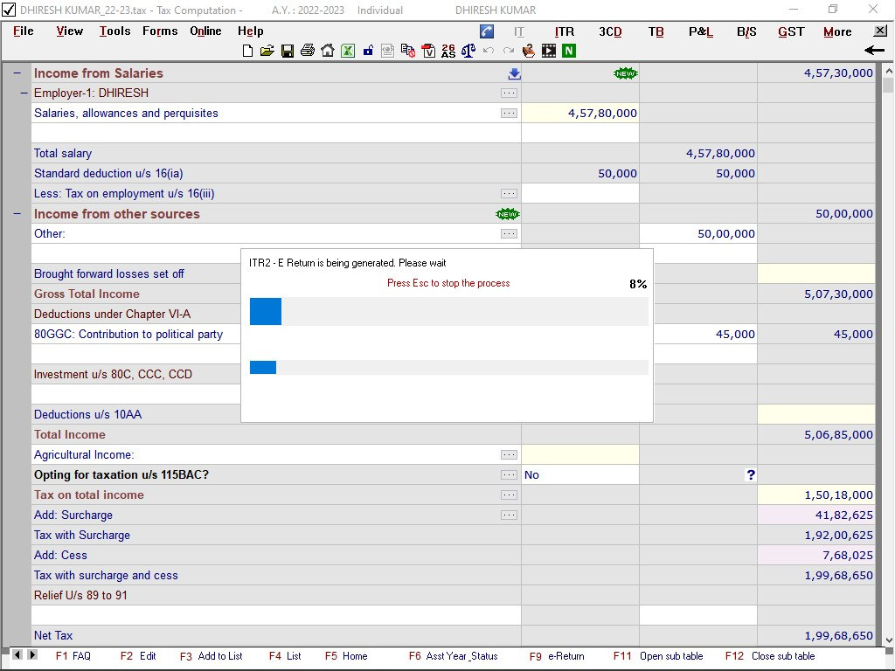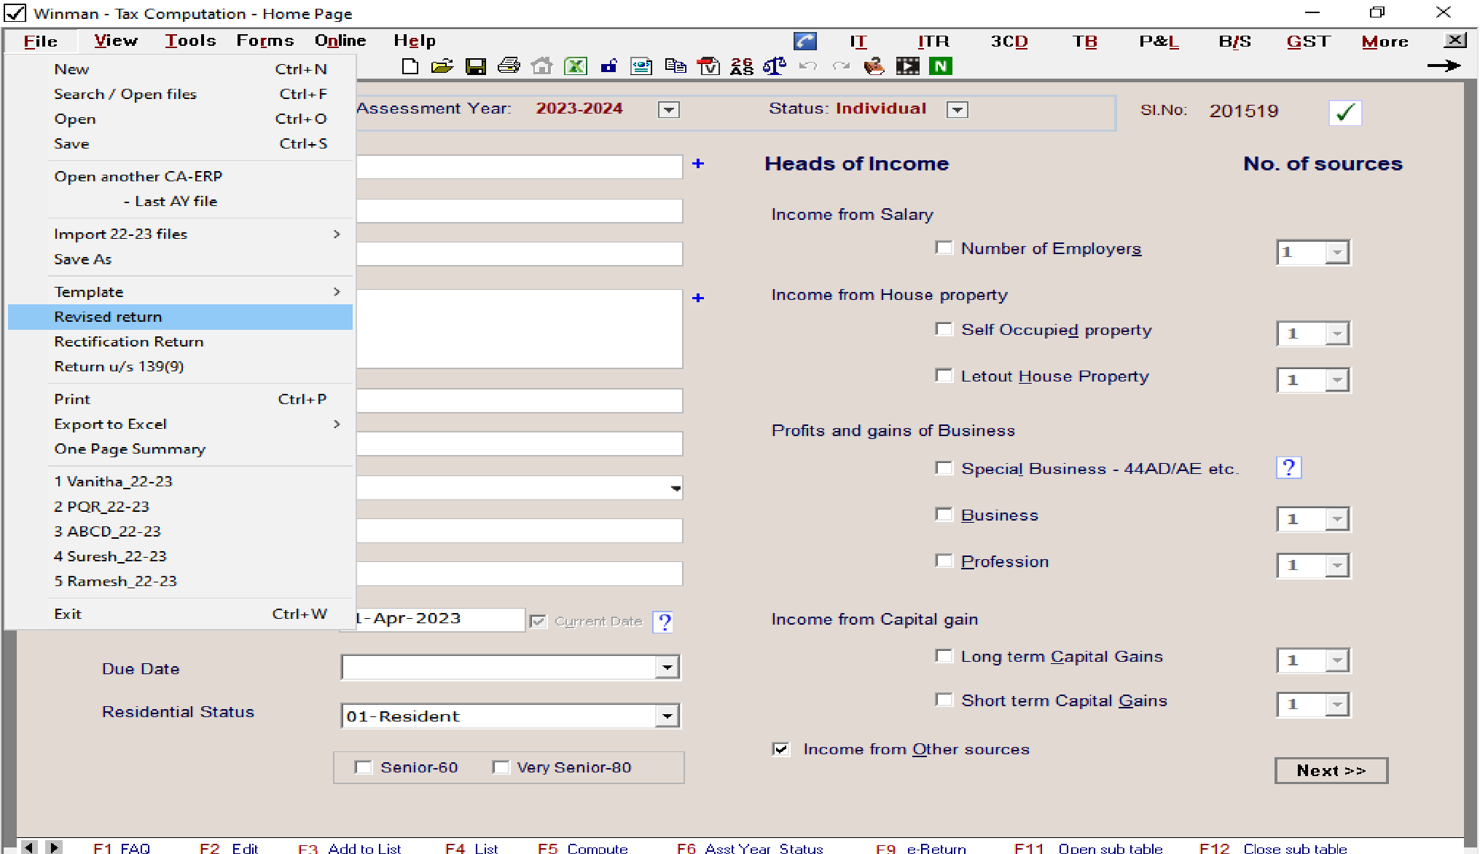

**GST Filing:**

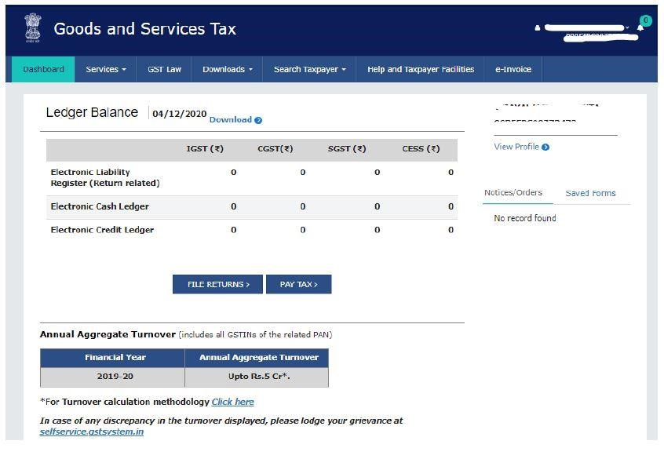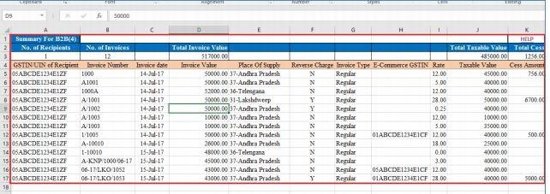

# CHAPTER 3 LEARNING OUTCOME/

# EXPERIENCE

**Learning Outcomes and Internship Experience**

**Introduction:**

This chapter reflects on the valuable learning outcomes and enriching experiences I gained during my internship at Vikram and Gaurav Chartered Accountants. The internship program provided a comprehensive introduction to the world of accounting, taxation, and auditing, equipping me with both theoretical knowledge and practical skills.

**Key Learning Areas:**

The internship offered a well-structured learning journey. My guide, Gaurav S.R., played a crucial role in this by conducting dedicated 2-hour daily training sessions on various topics:

* **Understanding Accounting Principles:** These sessions provided a strong foundation in accounting principles, including the double-entry system, journalizing transactions, and preparing financial statements. This knowledge proved invaluable throughout the internship, enabling me to effectively contribute to various tasks.
* **Taxation (Income Tax, GST, TDS):** I gained detailed knowledge of tax regulations through training on Income Tax, Goods and Services Tax (GST), and Tax Deducted at Source (TDS). This included understanding filing procedures, tax calculations, and compliance requirements. o**Income Tax:** I learned about tax brackets, deductions, and exemptions, further enhanced by assisting with tax return preparation using Winman software.
  + **GST:** The training sessions provided in-depth knowledge of the GST framework. I gained practical experience in filing GST returns for numerous companies, which included understanding registration procedures, classification of transactions, calculating tax liabilities, and claiming input tax credit.

* + **TDS:** The training covered the fundamentals of TDS, including identifying situations where TDS applies, calculating TDS rates, and depositing TDS with the government.
* **Accounting Software:** I learned about accounting software used in the firm, including Winman for income tax filing and Tally for comprehensive accounting tasks. This experience enhanced my computer literacy and prepared me to adapt to various accounting software used in the professional world.

**Challenges and Overcoming Them:**

While the internship was enriching, I did encounter some initial challenges:

* **Limited Team Support:** Initially, I experienced a lack of team support from colleagues. This made the learning curve steeper, as I couldn't readily access guidance from peers. However, I communicated this to Gaurav S.R., who facilitated better integration within the team. Over time, the team became more cooperative, fostering a collaborative work environment.
* **Time Management during Book Closing:** Reconciling bank transactions for book closing for tax audit was particularly time-consuming. The fast pace in the initial stages made it difficult to complete reconciliations accurately. To address this, I discussed strategies with Gaurav S.R. I was advised to follow a systematic approach by prioritizing high-value transactions and breaking down the workload into manageable tasks. This improved my time management skills and ensured accurate reconciliations by the end of the internship.

**Practical Skill Development:**

Through the internship, I actively participated in various tasks, allowing me to develop crucial practical skills:

* **Data Entry and Record-Keeping:** I honed my data entry skills by using accounting software like Winman and Tally to record financial transactions for clients, ensuring accuracy and adherence to accounting standards.
* **Communication and Client Interaction:** Throughout the internship, I had the opportunity to interact with clients, either through emails, phone calls, or in-person interactions This helped me develop communication skills and the ability to explain complex accounting and tax concepts in a clear and concise manner.
* **Software Skills:** I gained practical experience using Winman software for income tax filing and Microsoft Excel for organizing data for GST filing. Additionally, I learned the basics of Tally, a comprehensive accounting software. This enhanced my computer literacy and prepared me to adapt to various accounting software used in the professional world.
* **Problem-Solving and Analytical Skills:** While assisting with tasks like book closing, I developed problem-solving and analytical skills. Identifying discrepancies in bank reconciliations and researching solutions enhanced my ability to approach challenges methodically.

**Overall Experience**

Despite initial challenges, the internship at Vikram and Gaurav Chartered Accountants was a truly enriching experience. The combination of theoretical knowledge and practical application provided a holistic understanding of the accounting and tax profession. I particularly enjoyed working a dynamic and workaholic environment where each and every member in the organization was always ready to take up work and this would motivate me always to contribute more creating a team bonding and learning Tally software basics also interested me to learn more in it.

The supportive and encouraging environment at the firm, particularly with Gaurav S.R.'s guidance, allowed me to ask questions and learn from experienced professionals. This internship has solidified my interest in pursuing a career in accounting.

**LOGBOOK**

|  |  |  |
| --- | --- | --- |
| **DATE** | **TIME** | **WORK DONE** |
| 21/03/2024 | 2PM-7PM | Introduction about the organization and meeting my team |
| 22/03/2024 | 2PM-7PM | Started to learn about the basics of GST{Introduction} |
| 23/03/2024 | 2PM-7PM | Learnt about Place, Time and Value of Supply{GST} |
| 25/03/2024 | 2PM-7PM | Learnt about IGST,UTGST,SGST,CGST |
| 26/03/2024 | 2PM-7PM | Learnt about Input tax credit{ITC} & Reverse Charge  Mechanism{RCM} |
| 27/03/2024 | 2PM-7PM Learnt about various filings of GSTR and tax slabs for various products | |
| 28/03/2024 | 2PM-7PM | Started to learn about basics of Income Tax |
| 29/03/2024 | 2PM-7PM | Learnt about the various deductions U/S 80 & U/S 10 |
| 30/03/2024 | 2PM-7PM | Learnt all the standard procedures for filing Income tax such as Standard Deduction and U/S 115 BAC |
| 01/04/2024 | 2PM-7PM | Learnt the basics of Advance Tax and how it is calculated.. |
| 02/04/2024 | 2PM-7PM | My team Introduced me to the practical way of filing GSTR. |
| 03/04/2024 | 2PM-7PM | Filed GSTR 1 for 8 companies. |
| 04/04/2024 | 2PM-7PM | Filed GSTR 1 for another 10 companies. |
| 05/04/2024 | 2PM-7PM | Was introduced to the Winman Software and how the Income tax through Form 16 is obtained and filed. |
| 06/04/2024 | 2PM-7PM | Filed Income Tax for a salaried individual of imaginary figures. |

***ANNEXURES***

PICTURE OF COMPANY:



**Bibliography**

* Focused on the specific CA exam level books which was relevant to my internship and searched online for the most recommended textbooks for Income Tax and Goods and Services Tax (GST) and found "Taxmann's Students' Guide to Income Tax

Including GST" by Vinod Kumar Gupta, Taxmann Publications Pvt. Ltd., 2023”.

* **Websites:** I used the official websites for the Central Board of Indirect Taxes and Customs (CBIC) GST portal for collecting additional Information to make my internship report more precise. [(https://www.gst.gov.in/)](https://www.gst.gov.in/) and Winman Software [(https://www.winman.com/)](https://www.winman.com/) for reference.

Thank you..